**Table S3.** Summary of putative transcription site mapping. [Note that the published sequences need references added.]

|  |  |  |  |  |
| --- | --- | --- | --- | --- |
| **Strain** | **Gene** | **Putative TS\*** | **-35** | **-10** |
| *M. trichosporium* OB3b | *pmoC* | -273 | **TTG**T**CA** | AATGGTTG |
|  | *pmoC* | -324 | **ttg**tgc | tcctacccTA |
|  | *mxaF* | -156 | CA**GACA** | **TATA**TG |
|  | *fae1* | -214 | **TT**CGAT | **TATA**AT |
|  | *pqqA* | -90 | **TTG**CAC | GC**TAAT** |
| *Methylocystis* sp. M1 | *pmoC* |  | **TTG**T**CA** | GA**AT**GG**T**TG |
| *M.extorquens* AM12 | *mxaF* |  | AA**GACA** | **TA**G**AA**A |
|  | *mxaW* |  | **TTG**GCA | ACCCAT |
| *E. coli 3* | σ70 |  | **TTGACA** | **TATAAT** |
|  | σ32 |  | TCTCNCCCTTGAA |  |
|  | σ54 |  | CTGGNA | TTGCA |
|  | σ28 |  | CTAAA | CCGATAT |

1 Holmes *et al.*, 1995 (see Ref)

2. Zhang, M., and Lidstrom, M.E. (2003) Microbiol 149:1033-40.

3. [Harley, C.B](http://www.ncbi.nlm.nih.gov/pubmed?term=Harley%20CB%5BAuthor%5D&cauthor=true&cauthor_uid=3550697)., and [Reynolds, R.P](http://www.ncbi.nlm.nih.gov/pubmed?term=Reynolds%20RP%5BAuthor%5D&cauthor=true&cauthor_uid=3550697). 1987, Nucleic Acids Res. 11:2343-61

**Table S4.** Summary of RNA-seq (Illumina) reads

|  |  |  |  |  |
| --- | --- | --- | --- | --- |
|  | Reads Mapped | | % of Reads Mapped | |
|  | Replicate 1 | Replicate 2 | Replicate 1 | Replicate 2 |
| Coding sequences | 3.652*106 | 1.546*106 | 13.3 | 5.44 |
| Noncoding sequences | 2.935*105 | 1.396.*105 | 1.07 | 0.49 |
| rRNA | 2.359*107 | 2.671*107 | 85.6 | 94.0 |
| tRNA | 7.937*103 | 4.095*103 | 0.029 | 0.0014 |

**Table S5.** Genes removed from reference scaffold before alignment

|  |  |
| --- | --- |
| **Locus tag** | **Comment** |
| METTOv1_1600001 | chimeric sequence/ METTOv1_870001 and METTOv1_870003 |
| METTOv1_820016 | protein of unknown function |
| METTOv1_150030 | protein of unknown function |
| METTOv1_300034 | protein of unknown function/gltD operon |
| METTOv1_1650001 | chimeric sequence/part of METATv1_30343 and METATv1_30340 |
| METTOv1_140042 | chimeric protein/part of METTOv1_140043 |
| METTOv1_1700001 | chimeric sequence/METTOv1_870001 and METTOv1_870003 |
| METTOv1_10052 | chimeric protein/part of METTOv1_10051 |
| METTOv1_200054 | chimeric protein/part of METTOv1_200053 |
| METTOv1_600024 | exported protein of unknown function |
| METTOv1_370034 | protein of unknown function |
| METTOv1_200053 | protein of unknown function |
| METTOv1_720016 | protein of unknown function |
| METTOv1_450003 | protein of unknown function |
| METTOv1_590015 | protein of unknown function |
| METTOv1_360021 | protein of unknown function |
| METTOv1_800023 | protein of unknown function//part of transposase IS3/IS911 |
| METTOv1_760015 | protein of unknown function |
| METTOv1_270007 | protein of unknown function |
| METTOv1_210063 | protein of unknown function |
| METTOv1_10194 | protein of unknown function |
| METTOv1_200055 | protein of unknown function |
| METTOv1_450005 | protein of unknown function |
| METTOv1_1280001 | protein of unknown function |
| METTOv1_1050002 | protein of unknown function |
| METTOv1_160016 | protein of unknown function |
| METTOv1_200057 | protein of unknown function |
| METTOv1_260041 | protein of unknown function |
| METTOv1_600022 | exported protein of unknown function |
| METTOv1_870007 | protein of unknown function |
| METTOv1_260040 | protein of unknown function |
| METTOv1_90064 | protein of unknown function |
| METTOv1_30137 | exported protein of unknown function |
| METTOv1_590023 | protein of unknown function |
| METTOv1_250030 | protein of unknown function |
| METTOv1_360046 | protein of unknown function |
| METTOv1_830011 | protein of unknown function |

Supplemental Figure S1



Supplemental Figure S2

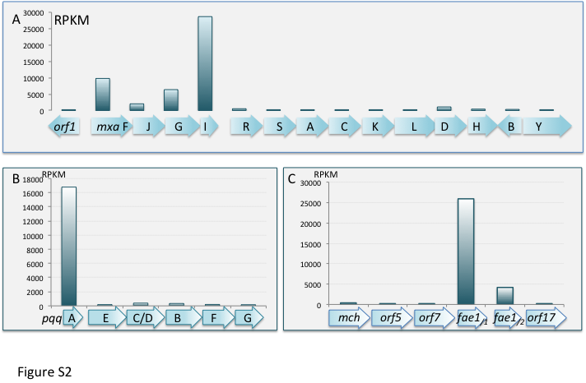

Supplemental Figure S3



Supplemental Figure S4



Supplemental Figure S5

